|  |  |  |  |
| --- | --- | --- | --- |
| Sr.no | Task Details | Start time | End time |
| 1. | Session | 9:40 | 11:20 |
| 2. | Implement Grid & table | 11:20 | 1:50 |
| 3. | lunch | 1:50 | 2:50 |
| 4. | Implement Button &cards | 2:50 | 4:00 |
| 5. | Session | 4:00 | 6:00 |
| 6. | Implement form & review code to  akash sir | 6:00 | 7:00 |

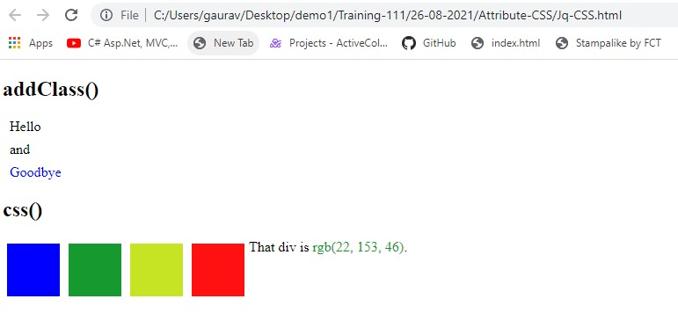

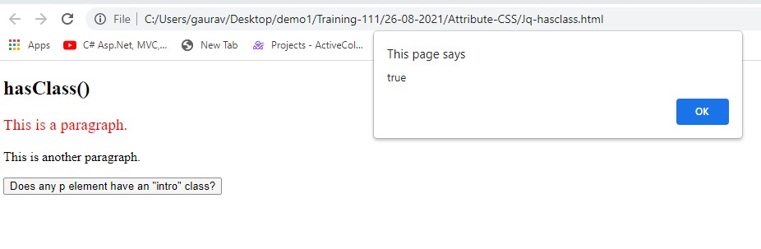

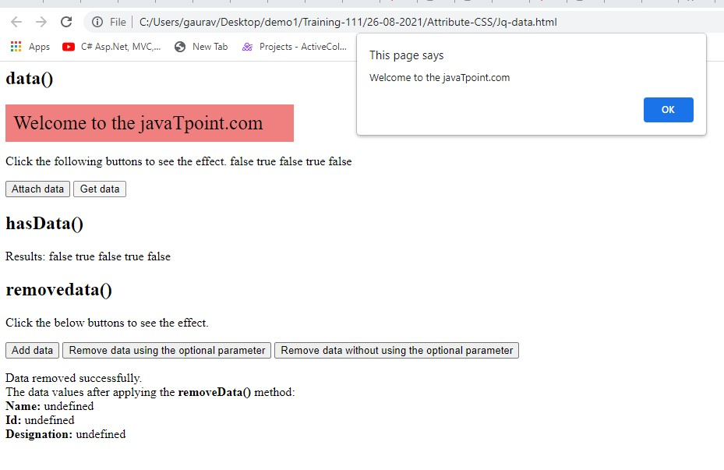

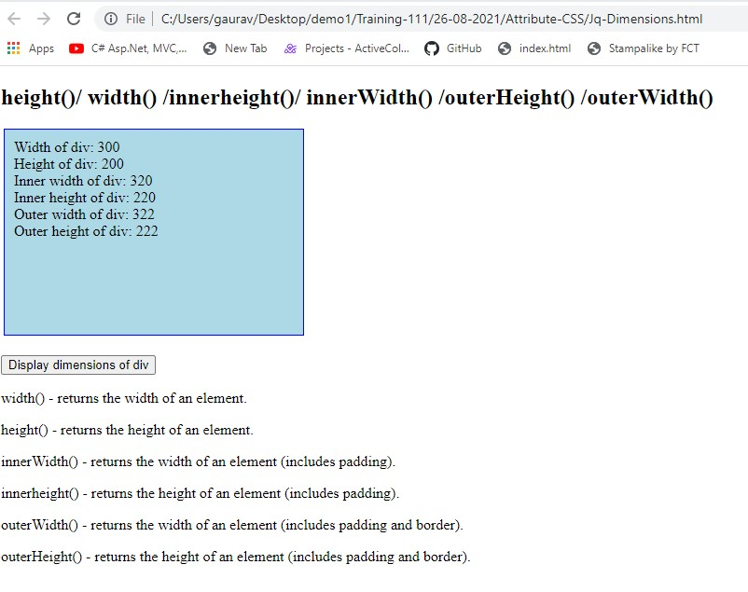

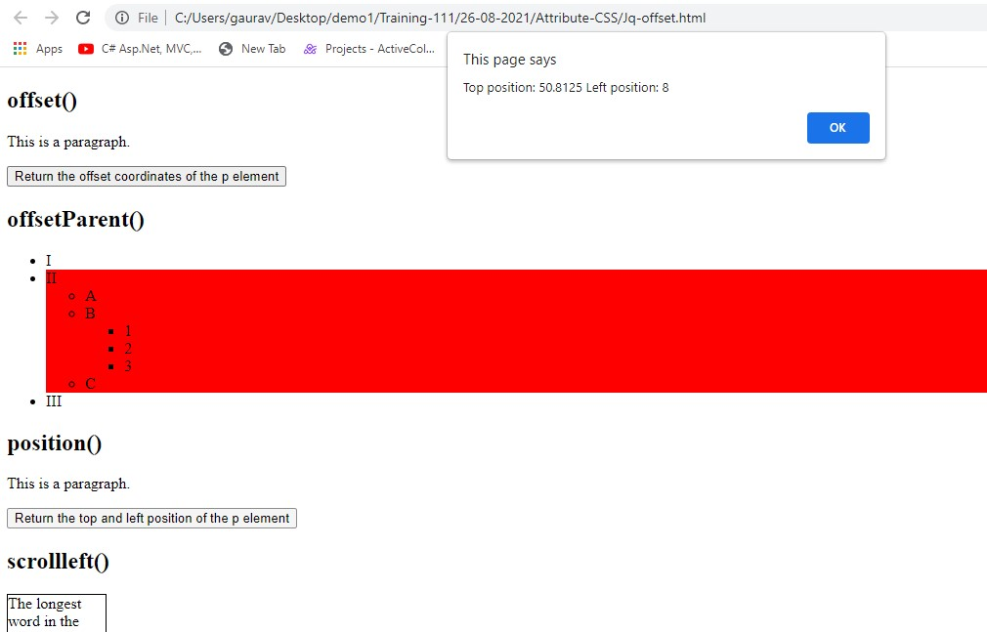

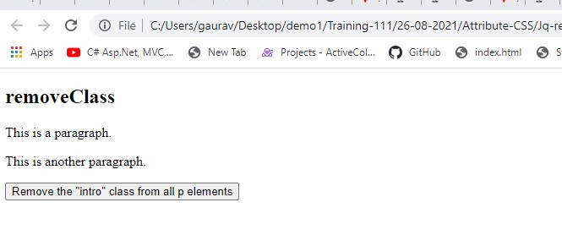

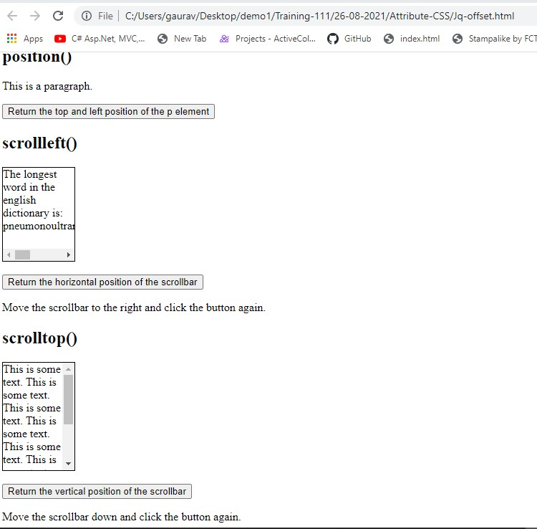

**Jquery Events:**

